14th October 2019

**TCR Europe crowns new Champion in Monza**

The legendary Italian race track of Monza witnessed the final rounds 13th & 14th of the TCR Europe series. The highly competitive series boasts Japanese premium tyre manufacturer YOKOHAMA as exclusive tyre supplier.

Pending final technical checks and ratification of the results*, the British driver Josh Files secured the TCR Europe title at the end of the very last race, in which he took his third win of the season beating a determined Julien Briché who never gave up.

The Briton had already staked a serious claim on the championship crown with a great recovery from P9 on the grid to finish third in Race 1. On the final race he ended his superb season in style with a superb race that saw him taking the lead early on and then building a small gap that enabled him to resist Briché’s attacks during the final laps.

The Frenchman had to recover 33 points in the standings and needed the closest thing to a miracle to succeed in this task. However, he tried until the very end, making a long series of overtaking moves to finish as runner-up in both the race and the championship.

Daniel Lloyd completed the podium after he was reinstated into third place by a ten-second penalty imposed on Aurélien Comte for gaining an unfair advantage during the final lap.

Amongst the other competitors, a mention is needed for the Uruguayan Santiago Urrutia, who scored a sixth place that rewarded him with third position in the final standings ahead of Andreas Bäckman. Dominik Baumann completed a great recovery from 23rd on the grid to tenth at the end of the race; a result that was denied to the Brazilian rookie Guilherme Salas who started from P28, climbed to 14th, but retired on the final lap with a technical issue.

At the end of the weekend, a spokesman for YOKOHAMA Europe praised the drivers and teams for their efforts throughout the season and congratulated the winners.

Final Driver standings*:

1. Josh Files 352 pts.

2. Julien Briché 314 pts.

3. Santiago Urrutia 234 pts.

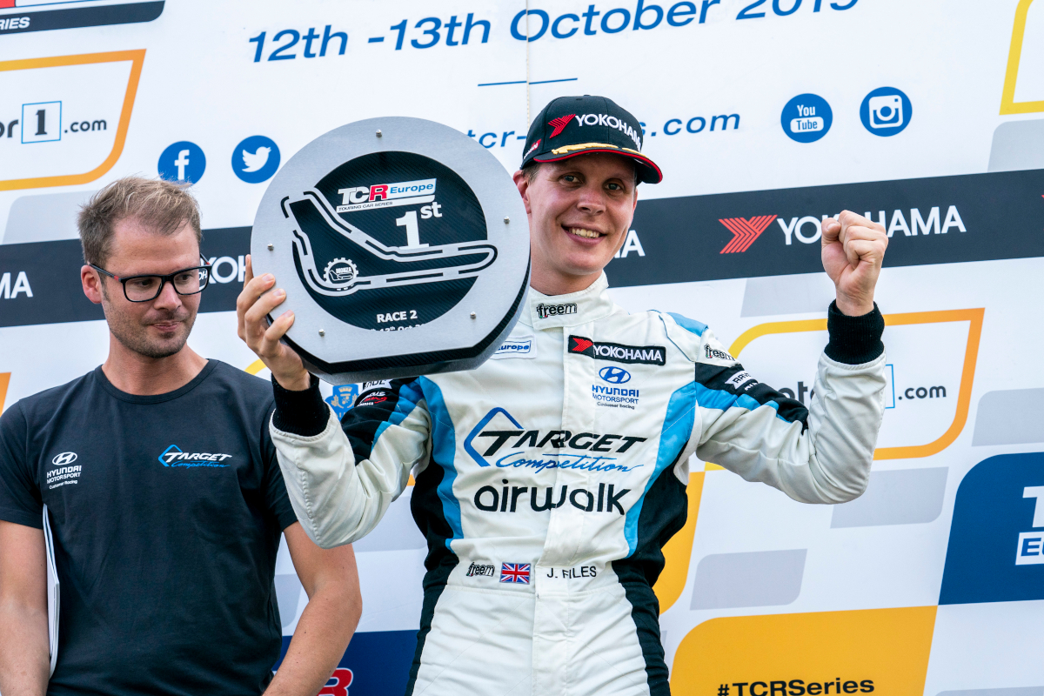

*2019 - 2019 Monza Race 2---2019 EUR Monza R2, podium Josh Files_48*

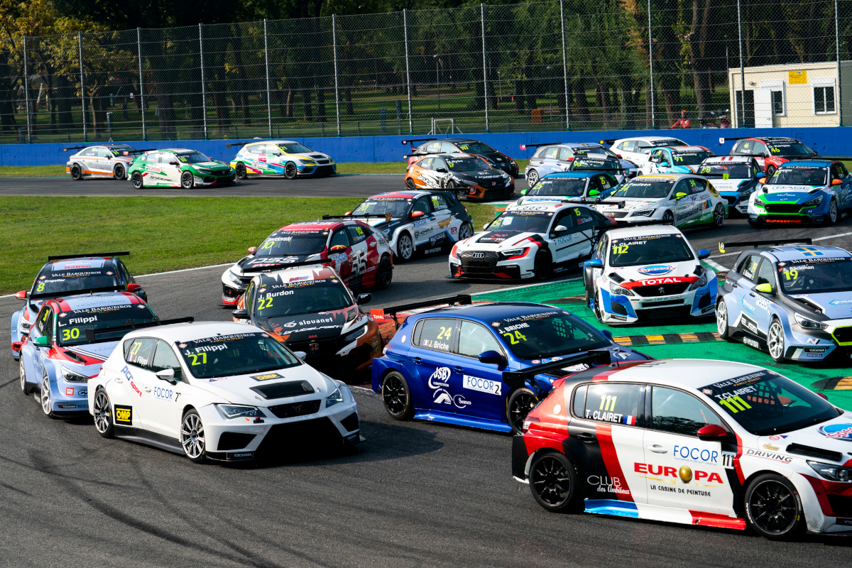

*2019 - 2019 Monza Race 2---2019 EUR Monza R2, start_29*